Ansible AAP integrates with VMware vCenter for VM DR between Data Centers
In this article, we will introduce how to use Ansible AAP to unregister specified vm from primary VMware data center and register to target data center as DR site. This scenario is also used for vm disaster recovery.

We will design a automation workflow to performing operation below:
1, Check capacity of DR site data store.
2, Send result by email to notify admin and wait for approval.
3, Once get approval, automatically power off vm on primary data center.
4, Unregister vm from primary site data center and register to DR site data center.
5, Power on vm on DR site data center and assign new IP, gateway, dns as demand, then auto startup application(httpd).
6, Email notify admin if above done.

Prerequisites：
- Ansible Automation Platform 2.5+ installed
- EE for VMware integration has been created
- On VMware vCenter UI:
  - Primary site data center: “Beijing_dc02”
  - DR site data center: “Shenzhen_dc01” and a cluster with name “Cluster01” is under the data center
  - A vm with name “RHEL8.10-DR-Test”, which is in directory “VMware-Lab” and “Beijing_dc02”
- Theoretically, primary and DR site data center are using same data store which is usually shared storage, or primary and DR site data store can keep data sync all the time. For POC or testing purpose, we will copy vm config file(with .vmx suffix) and disk image file(with .vmdk suffix) of “RHEL8.10-DR-Test” to DR site data store for simulation.

The environment for vm DR between data center：
Role | Hostname | IP | Comment
AAP Controller 2.5 on RHEL 9.5 | aap25-jw.example.com | 10.66.208.239
VMware vCenter 7.0+ |  | 10.71.18.138
Primary site data center “Beijing_dc02”
DR site data center “Shenzhen_dc01”
A Linux(RHEL 8.10) vm with name RHEL8.10-DR-Test

Preparation：

- Check VM “RHEL8.10-DR-Test” at first, it’s original running on primary site data center “Beijing_dc02”, under “VMware_Lab” directory.
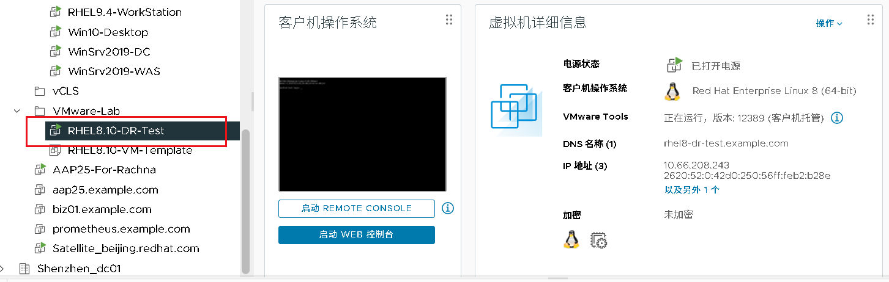

2, In vm, make sure vmware-tools and perl installed:
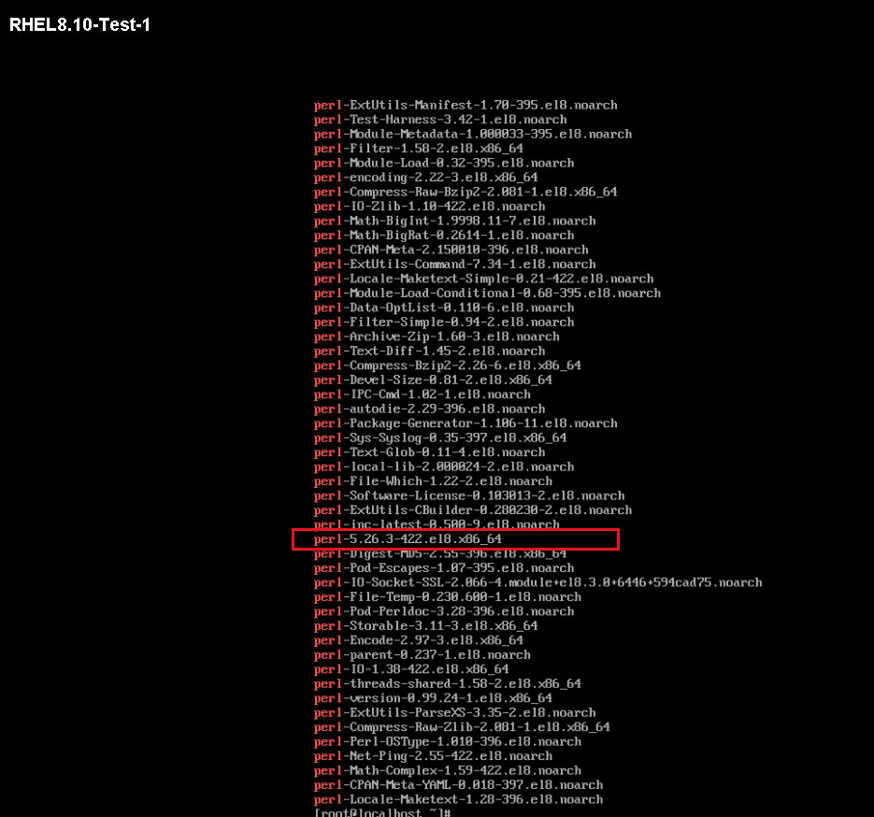

- Based on vCenter admin username and password create credential：
In my lab, vCenter IP is 10.71.18.138, admin username and password is：
administrator@vsphere.local
Your_password

So create a credential with name “vc_credential” and type “VMware vCenter” as following:
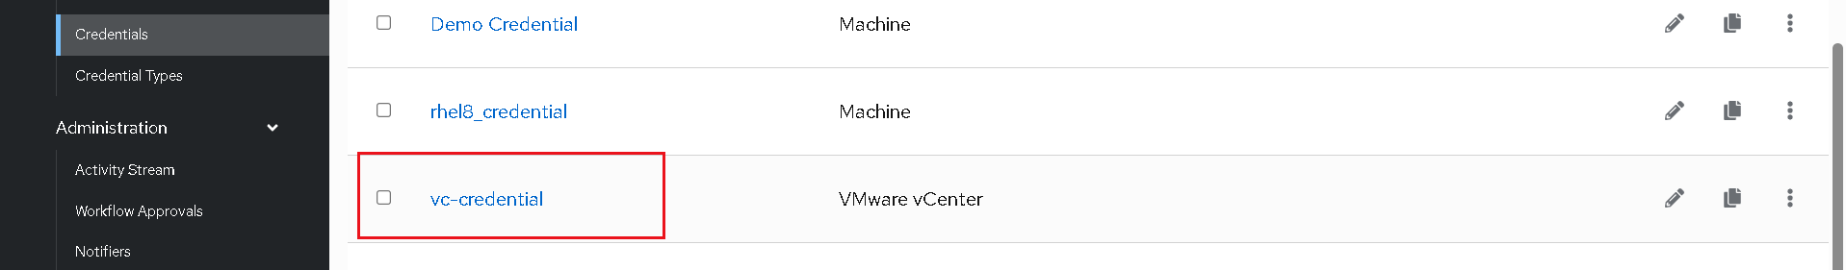
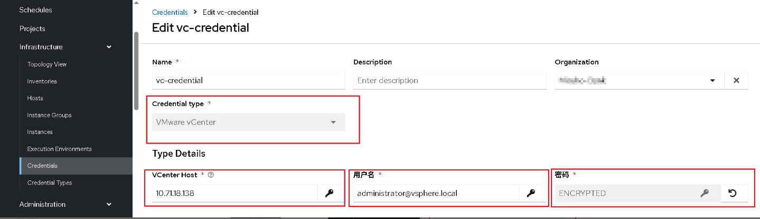

Since calling vCenter to execute VMware modules and collections is generally done on AAP, playbook tasks are usually executed locally on AAP via delegate_to: localhost or aap. Therefore, there is no need to create an inventory for VMware on the AAP UI.

- Ensure that the AAP controller's project directory contains a complete ansible.cfg file (encapsulated within a custom EE), an inventory file, and a complete collection (for local testing).
[admin@aap25-jw example-project]$ cat ansible.cfg
[defaults]
inventory = ./inventory
remote_user = admin

[privilege_escalation]
become = true
become_method = sudo
become_user = root
become_ask_pass = false

- Setup notifier on AAP：
Create a email notifier on AAP Web UI as example blow:
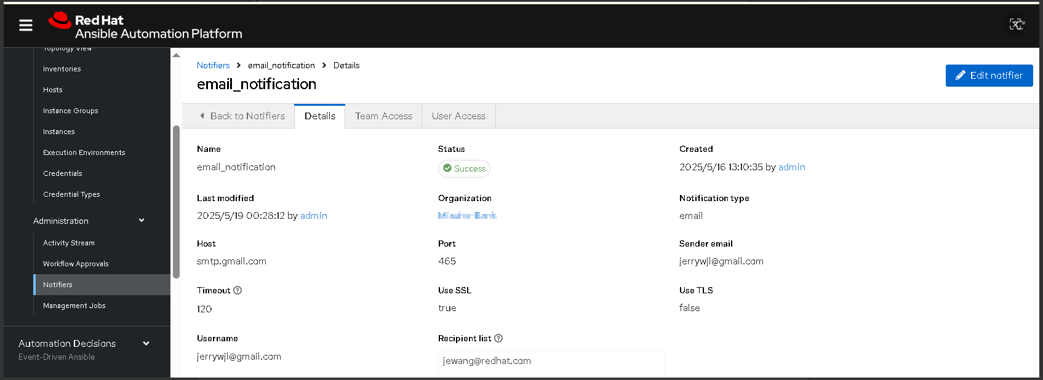

Steps for create the Automation Workflow：

- Create the first playbook, linux_dr_check.yml, content of playbook as below:
[admin@aap25-jw example-project]$ cat linux_dr_check.yml
---
- name: VMware Disaster Recovery Info Check
hosts: localhost
gather_facts: false
vars:
datacenter_primary: ""
datacenter_dr: ""
cluster_primary: ""
cluster_dr: ""
esxi_host_primary: ""
esxi_host_dr: ""
target_data_store: ""
vm_name: ""
validate_certs: false

mail_host: smtp.gmail.com
mail_port: 465
mail_username: jerrywjl@gmail.com
mail_password: YOUR_EMAIL_PASSWORD
mail_to: jewang@redhat.com

tasks:
- name: Check datastore info in DR site
community.vmware.vmware_datastore_info:
hostname: "{{ lookup('env', 'VMWARE_HOST') }}"
username: "{{ lookup('env', 'VMWARE_USER') }}"
password: "{{ lookup('env', 'VMWARE_PASSWORD') }}"
datacenter: "{{ datacenter_dr }}"
name: "{{ target_data_store }}"
validate_certs: "{{ validate_certs }}"
delegate_to: localhost
register: datastore_info

- name: Query content in specified datastore
community.vmware.vsphere_file:
hostname: "{{ lookup('env', 'VMWARE_HOST') }}"
username: "{{ lookup('env', 'VMWARE_USER') }}"
password: "{{ lookup('env', 'VMWARE_PASSWORD') }}"
datacenter: "{{ datacenter_dr }}"
datastore: "{{ target_data_store }}"
path: "{{ vm_name }}"
state: directory
validate_certs: "{{ validate_certs }}"
delegate_to: localhost
register: vm_folder_check
ignore_errors: true

- name: Print datastore info
ansible.builtin.debug:
var: datastore_info

- name: Print datastore content list
ansible.builtin.debug:
var: vm_folder_check

- name: Send DR Check Report via Email
community.general.mail:
host: "{{ mail_host }}"
port: "{{ mail_port }}"
username: "{{ mail_username }}"
password: "{{ mail_password }}"
to: "{{ mail_to }}"
subject: "[Ansible Report] VMware DR Site Check for {{ vm_name }}"
body: |
VMware DR Check Results

=== Datastore Info ===
{{ datastore_info | to_nice_json }}

=== VM Folder Check ===
{{ vm_folder_check | to_nice_json }}

delegate_to: localhost

Create the first job template with name "VM_DR_Datastore_Check" base on the playbook as below:
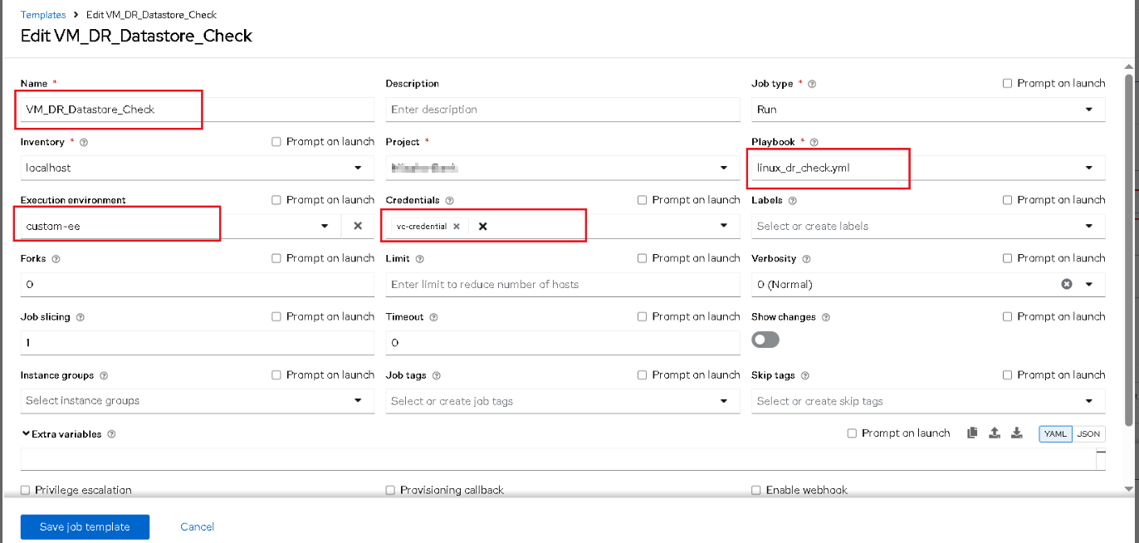

- Create the second playbook, linux_dr.yml, content of playbook as below:
[admin@aap25-jw example-project]$ cat linux_dr.yml
---
- name: VMware Disaster Recovery Failover
hosts: localhost
gather_facts: false
vars:
datacenter_primary: ""
datacenter_dr: ""
cluster_primary: ""
cluster_dr: ""
esxi_host_primary: ""
esxi_host_dr: ""
target_data_store: ""
vm_name: ""
validate_certs: false

tasks:
- name: Step 1 - Power off the VM on primary site
community.vmware.vmware_guest_powerstate:
hostname: "{{ lookup('env', 'VMWARE_HOST') }}"
username: "{{ lookup('env', 'VMWARE_USER') }}"
password: "{{ lookup('env', 'VMWARE_PASSWORD') }}"
validate_certs: "{{ validate_certs }}"
datacenter: "{{ datacenter_primary }}"
name: "{{ vm_name }}"
folder: "/vm"
state: powered-off
delegate_to: localhost
ignore_errors: true

- name: Step 2 - Unregister VM from primary site esxi server
community.vmware.vmware_guest_register_operation:
hostname: "{{ lookup('env', 'VMWARE_HOST') }}"
username: "{{ lookup('env', 'VMWARE_USER') }}"
password: "{{ lookup('env', 'VMWARE_PASSWORD') }}"
validate_certs: "{{ validate_certs }}"
datacenter: "{{ datacenter_primary }}"
esxi_hostname: "{{ esxi_host_primary }}"
folder: "/vm"
name: "{{ vm_name }}"
state: absent
delegate_to: localhost
ignore_errors: true

- name: Step 2 - Register VM to dr site esxi server
community.vmware.vmware_guest_register_operation:
hostname: "{{ lookup('env', 'VMWARE_HOST') }}"
username: "{{ lookup('env', 'VMWARE_USER') }}"
password: "{{ lookup('env', 'VMWARE_PASSWORD') }}"
validate_certs: "{{ validate_certs }}"
datacenter: "{{ datacenter_dr }}"
cluster: "{{ cluster_dr }}"
folder: "{{ datacenter_dr }}/vm"
name: "{{ vm_name }}"
# esxi_hostname: "{{ esxi_host_dr }}"
path: "[{{ target_data_store }}] {{ vm_name }}/{{ vm_name }}.vmx"
template: false
state: present
delegate_to: localhost

- name: Step 3 - Power on the recovered VM
community.vmware.vmware_guest_powerstate:
hostname: "{{ lookup('env', 'VMWARE_HOST') }}"
username: "{{ lookup('env', 'VMWARE_USER') }}"
password: "{{ lookup('env', 'VMWARE_PASSWORD') }}"
validate_certs: "{{ validate_certs }}"
datacenter: "{{ datacenter_dr }}"
name: "{{ vm_name }}"
folder: "/vm"
state: powered-on
delegate_to: localhost

Create the second job template with name "VM_DR_Operation" base on the playbook as below：
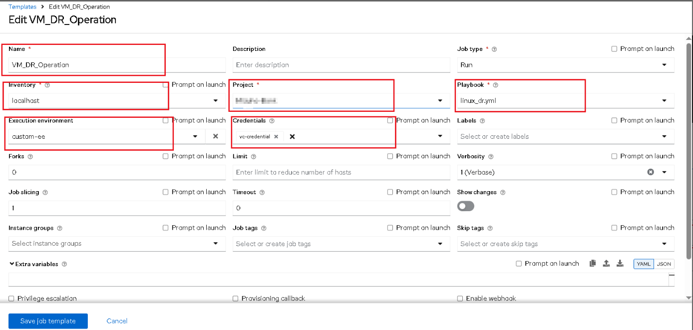

- Create the third playbook,linux_post_dr_setup_vm.yml, content of playbook as below:
[admin@aap25-jw mizuho-project]$ cat linux_post_dr_setup_vm.yml
---
- name: Configure recovered VM network after DR switch
hosts: localhost
become: yes
vars:
datacenter_dr: ""
vm_name: ""
network_interface: ""
vm_ip: ""
vm_netmask: ""
vm_gateway: ""
vm_dns:
- ""
- ""
vm_root_password: cmVkaGF0 # base64 encoded password

pre_tasks:
- name: Decode VM root password
ansible.builtin.set_fact:
decoded_vm_root_password: "{{ vm_root_password | b64decode }}"

tasks:
- name: Wait until VMware Tools are running
community.vmware.vmware_guest_tools_wait:
hostname: "{{ lookup('env', 'VMWARE_HOST') }}"
username: "{{ lookup('env', 'VMWARE_USER') }}"
password: "{{ lookup('env', 'VMWARE_PASSWORD') }}"
validate_certs: false
datacenter: "{{ datacenter_dr }}"
name: "{{ vm_name }}"
timeout: 300

- name: Run command inside a virtual machine with wait and timeout
community.vmware.vmware_vm_shell:
hostname: "{{ lookup('env', 'VMWARE_HOST') }}"
username: "{{ lookup('env', 'VMWARE_USER') }}"
password: "{{ lookup('env', 'VMWARE_PASSWORD') }}"
validate_certs: false
datacenter: "{{ datacenter_dr }}"
vm_id: "{{ vm_name }}"
vm_username: root
vm_password: "{{ decoded_vm_root_password }}"
vm_shell: /usr/bin/nmcli
vm_shell_args: >
connection modify {{ network_interface }}
ipv4.addresses {{ vm_ip }}/{{ vm_netmask }}
ipv4.gateway {{ vm_gateway }}
ipv4.dns {{ vm_dns | join(',') }}
ipv4.method manual
connection.autoconnect on
ipv6.method disabled
> /tmp/set_{{ network_interface }}.txt 2>&1
wait_for_process: true
timeout: 300
register: shell_command_with_wait_timeout

- name: Debug nmcli config output
debug:
var: shell_command_with_wait_timeout.stdout

- name: Apply and enable network
community.vmware.vmware_vm_shell:
hostname: "{{ lookup('env', 'VMWARE_HOST') }}"
username: "{{ lookup('env', 'VMWARE_USER') }}"
password: "{{ lookup('env', 'VMWARE_PASSWORD') }}"
validate_certs: false
datacenter: "{{ datacenter_dr }}"
vm_id: "{{ vm_name }}"
vm_username: root
vm_password: "{{ decoded_vm_root_password }}"
vm_shell: /usr/bin/nmcli
vm_shell_args: >
connection up {{ network_interface }}
> /tmp/apply_{{ network_interface }}.txt 2>&1
wait_for_process: true
timeout: 60
register: apply_network

- name: Debug nmcli apply output
debug:
var: apply_network.stdout

- name: Set vm_ip as a fact for workflow usage
ansible.builtin.set_stats:
data:
vm_ip: "{{ vm_ip }}"
per_host: false

- name: Add deployed VM to inventory
ansible.builtin.add_host:
name: "{{ vm_ip }}"
groups: provisioned

Create the third job template with name "VM_DR_Post_Config_VM" base on the playbook as below：
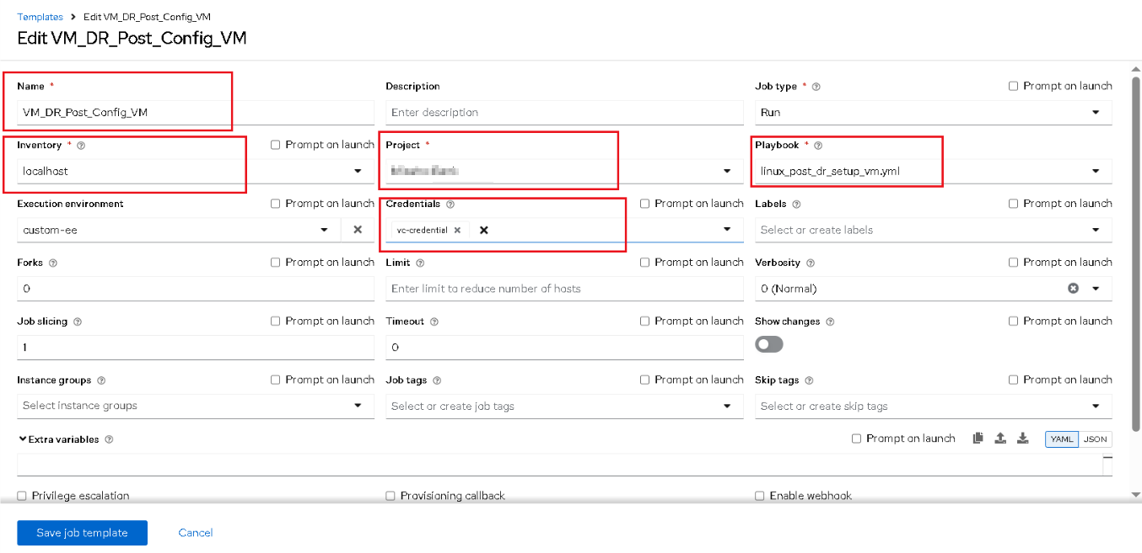

- Create the forth playbook,linux_post_dr_setup_vm.yml, content of playbook as below:
[admin@aap25-jw example-project]$ cat linux_post_dr_setup_app.yml
---
- name: Add dynamic host from previous playbook
hosts: localhost
gather_facts: false
tasks:
- name: Add VM to dynamic inventory
ansible.builtin.add_host:
name: "{{ vm_ip }}"
groups: provisioned

- name: Verify VM after DR - update hosts, start httpd, test service
hosts: provisioned
become: yes

tasks:
- name: Set hostname fact
ansible.builtin.set_fact:
hostname: "{{ ansible_hostname }}"

- name: Update existing entry in /etc/hosts with new IP
ansible.builtin.replace:
path: /etc/hosts
regexp: '^\d+\.\d+\.\d+\.\d+\s+.*\b{{ hostname }}\b'
replace: '{{ vm_ip }} {{ hostname }}'
backup: yes

- name: Ensure vm_ip and hostname are present in /etc/hosts if not matched above
ansible.builtin.lineinfile:
path: /etc/hosts
line: "{{ vm_ip }} {{ hostname }}"
state: present
create: yes
backup: no

- name: Start httpd service
ansible.builtin.service:
name: httpd
state: started
enabled: yes

- name: Wait for HTTP service on port 80 to be available
ansible.builtin.wait_for:
host: "{{ vm_ip }}"
port: 80
timeout: 30
state: started

- name: Check if httpd is responding on port 80
ansible.builtin.uri:
url: "http://{{ vm_ip }}"
return_content: no
status_code: 200

Create the forth job template with name "VM_DR_Post_Config_VM" base on the playbook as below：
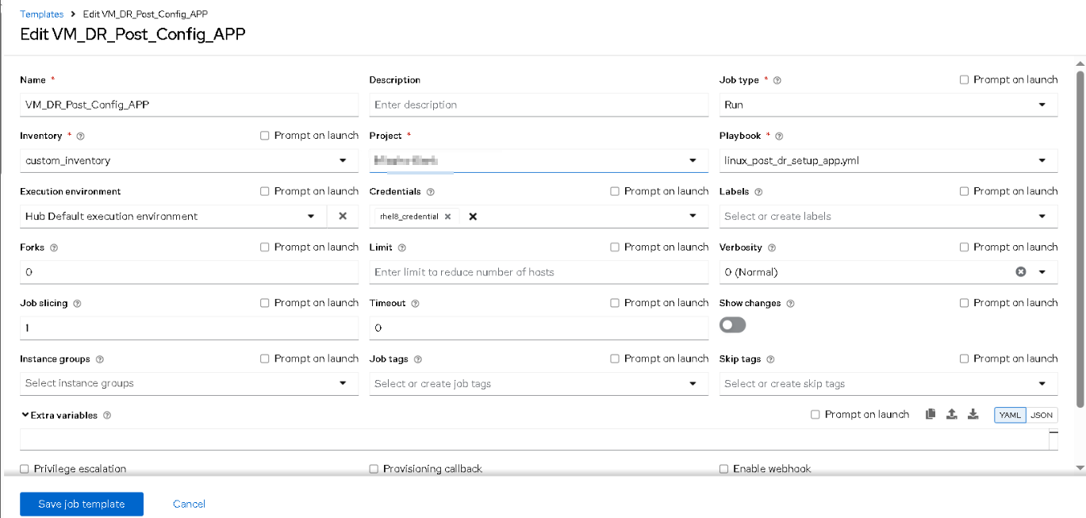

Note:
“custom_inventory” is only a place holder without any host, the host IP is as variables forward from previous playbook.
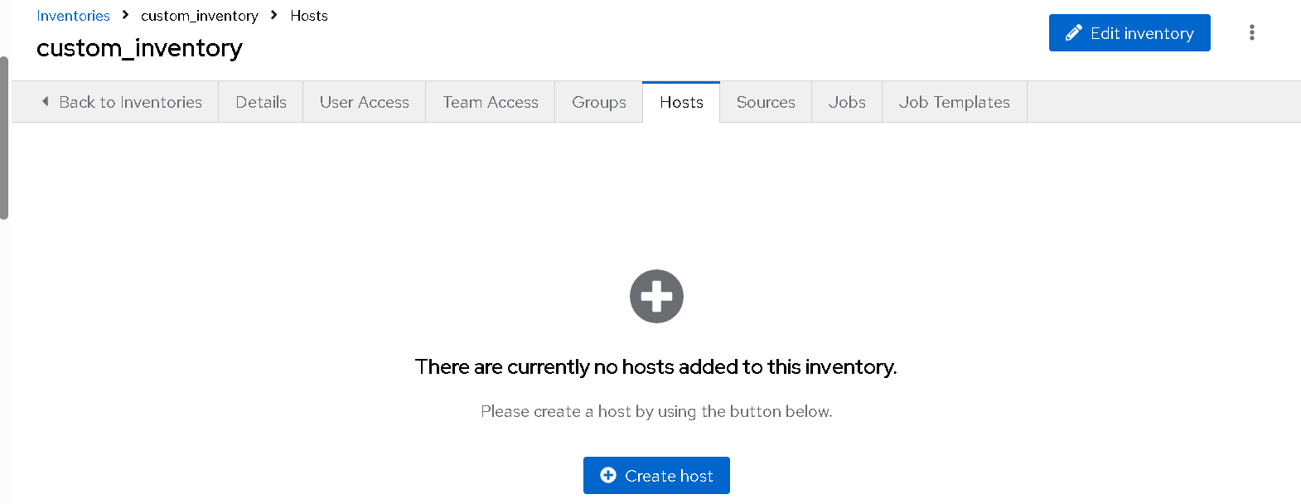

- Create the workflow job template with name “"Demo2-Linux_DR_with_New_Config_Setup”, which is consisted of the four Job template just created.
On AAP UI the process of workflow job template is as below:
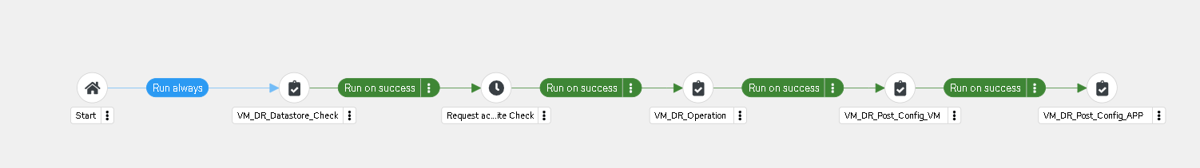

- Create a couple of survey on the workflow job template as below, based on my Lab env, survey type and content is as below:
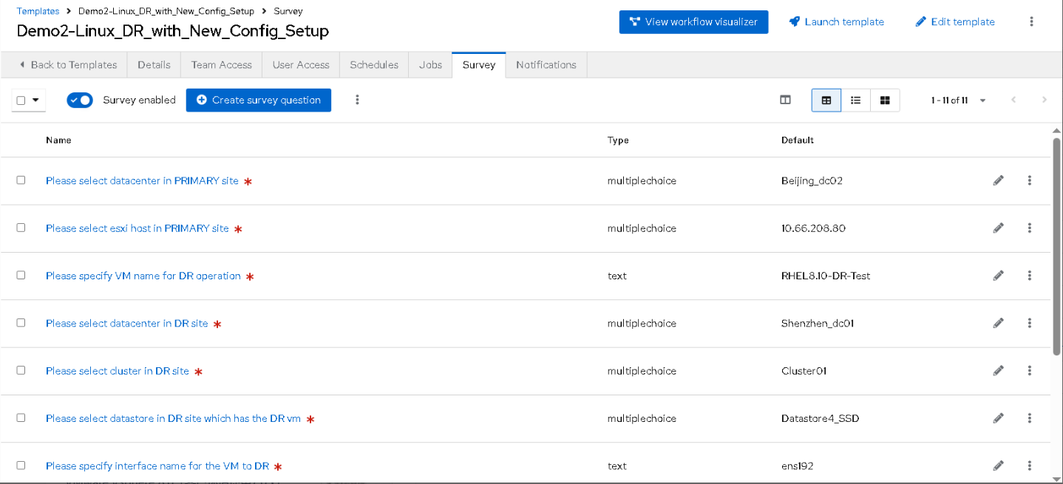
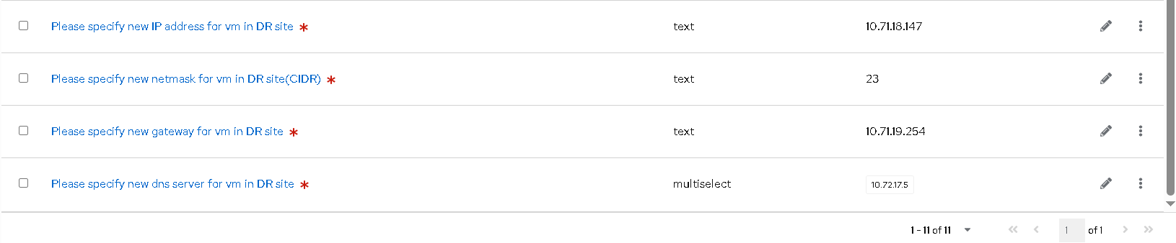

- When launch the workflow, you will need to input variables with survey above.
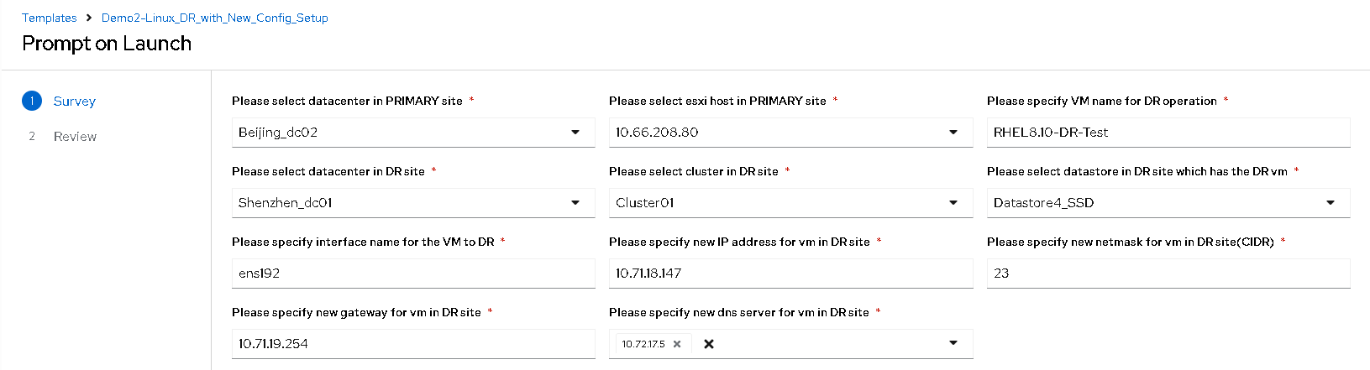
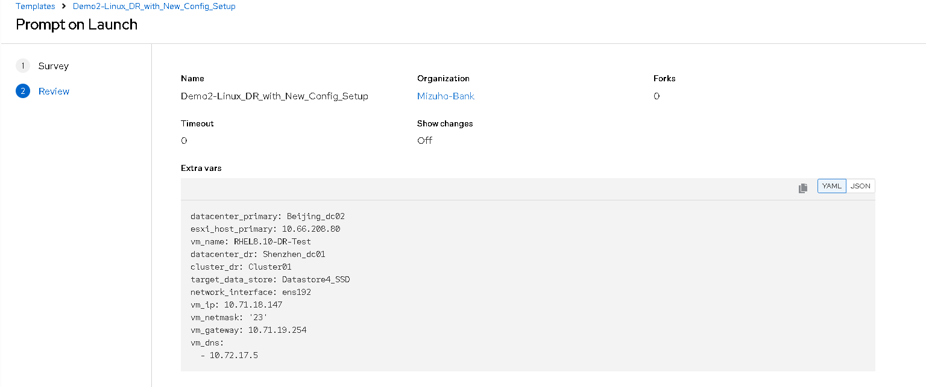

- Let’s add an approval between the first and the second job template as below:
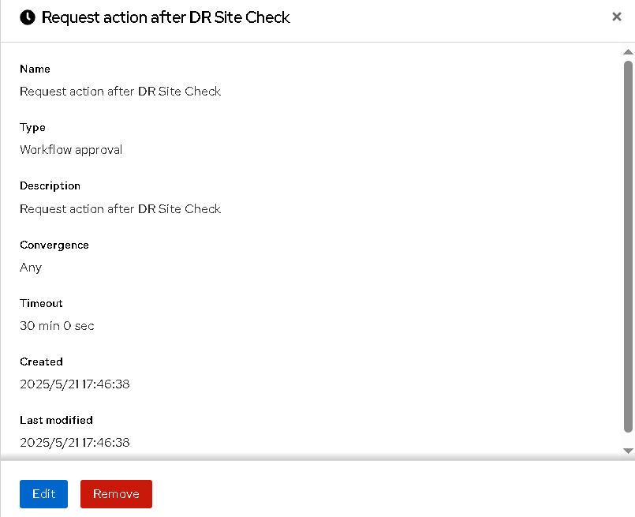

- Enable Email notification on the workflow job template:
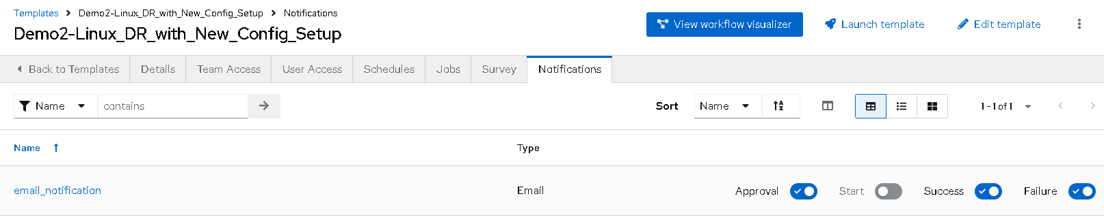

Steps for testing the workflow：
The whole workflow need to run about 10-15 mins, when the first job template complete, admin will get Email notification about target data store check on DR site as below:
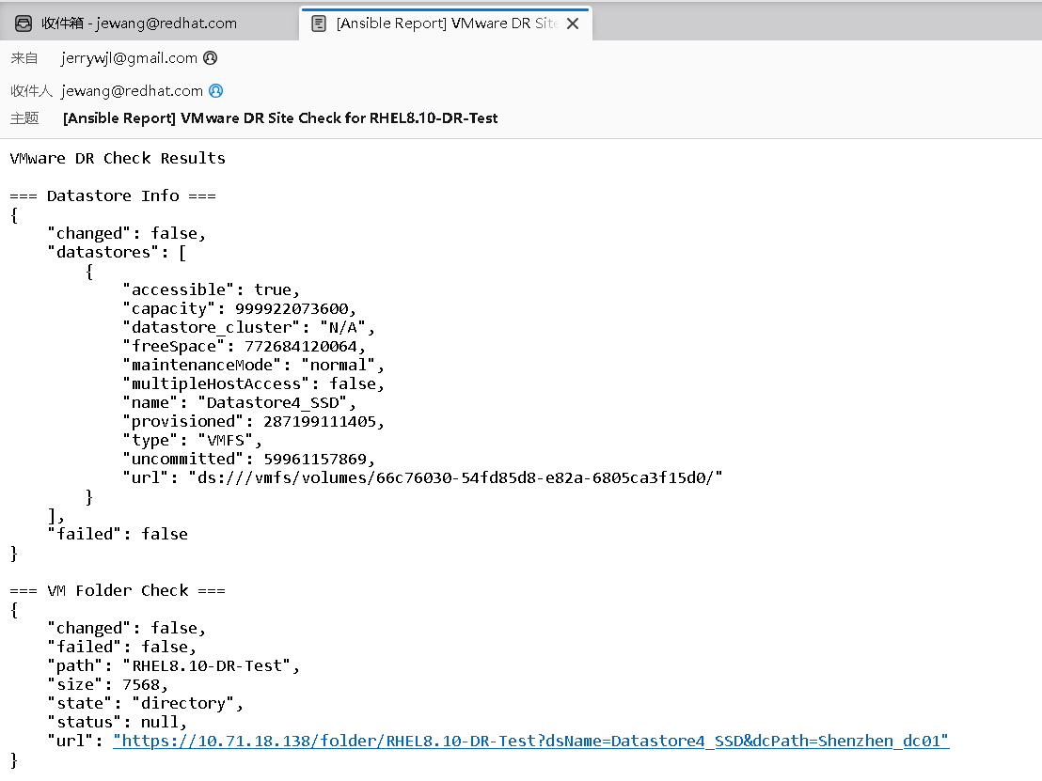

And another email will automatically sent to admin for approval:
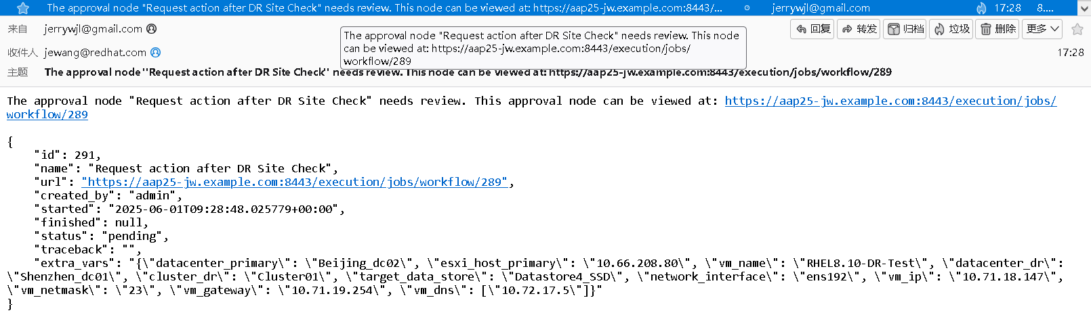

After approval the workflow will complete all job templates one by one.
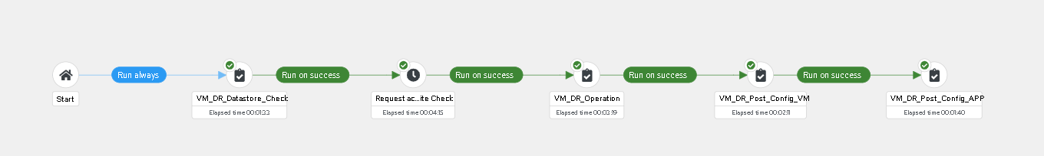
Can see vm is already running on new data center.
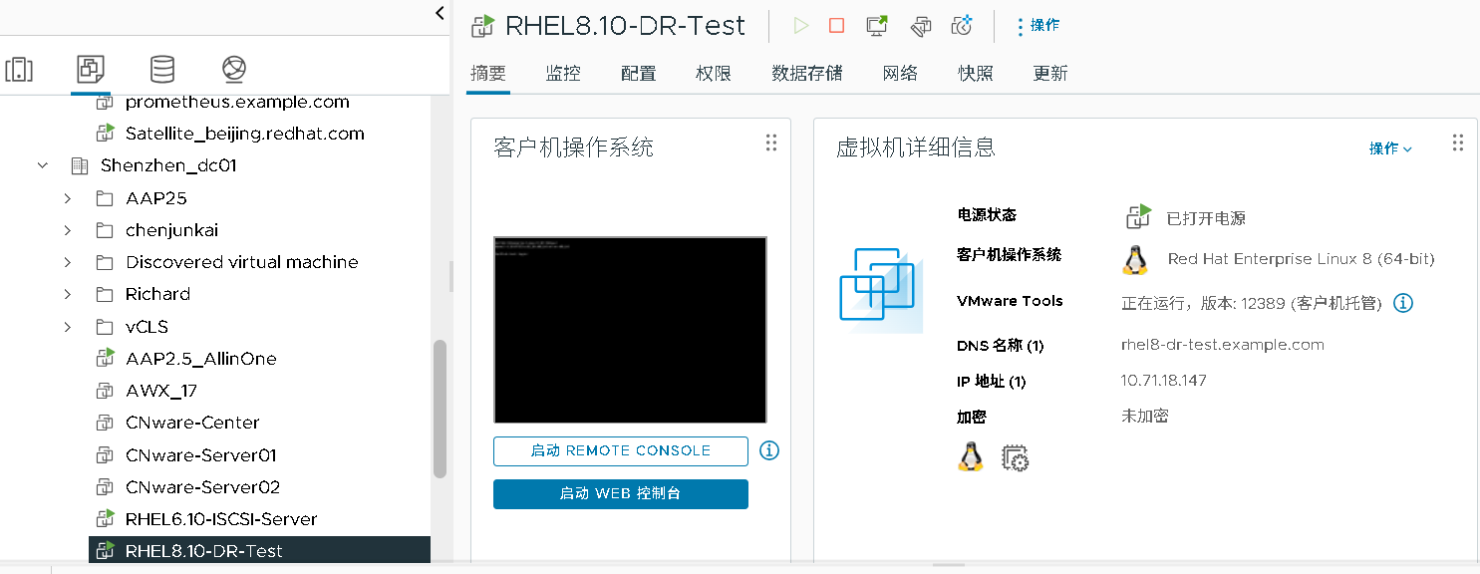

Admin will also get email about the workflow complete successfully.
